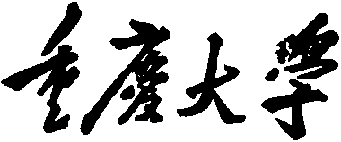 

**Personal Learning Portfolio**

**Course： English Academic Writing Teacher： Zhang Mei**

**Class： Major：**

**Name： Student Number：**

**Class Time： 2023.02-2023.07**

**Grade：**

|  |  |  |
| --- | --- | --- |
| **Self** | **Teaching Assistant** | **Teacher** |
|  |  |  |

**Comments：**

**Teacher (Signature)**

**Contents**

**Week 1**

1. **My learning**

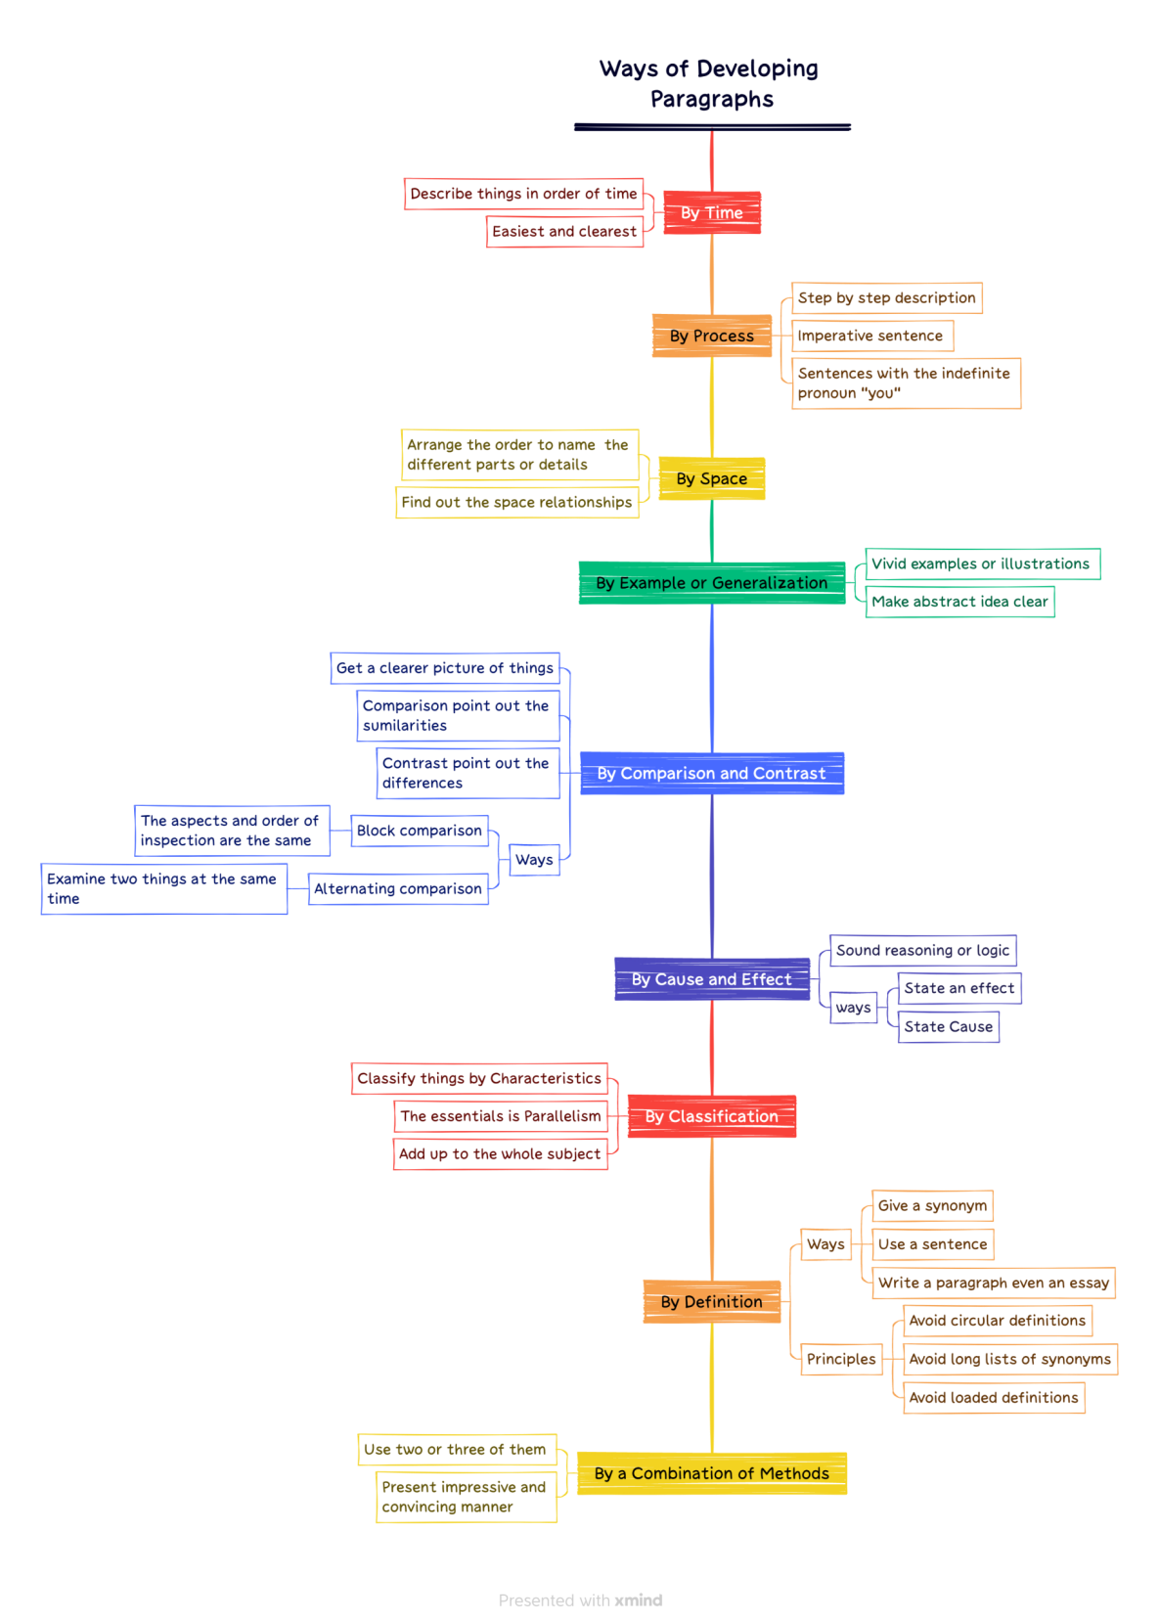

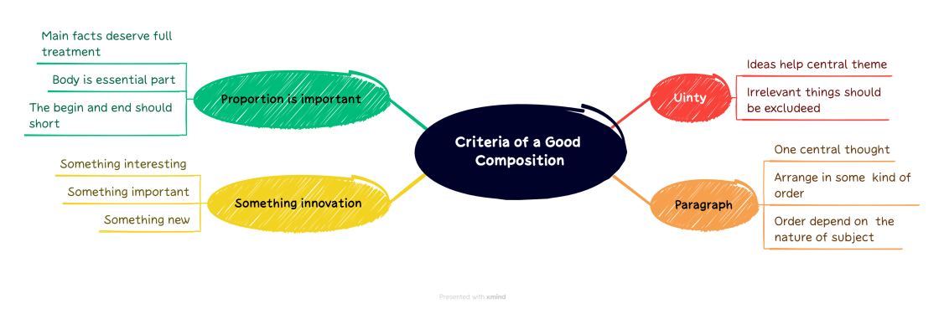

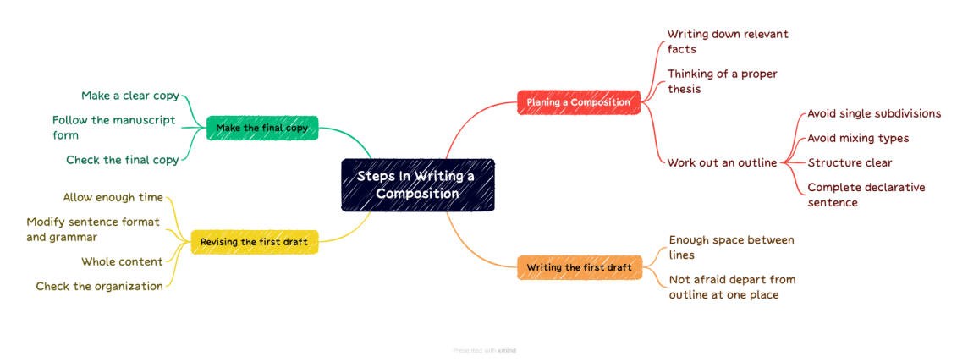

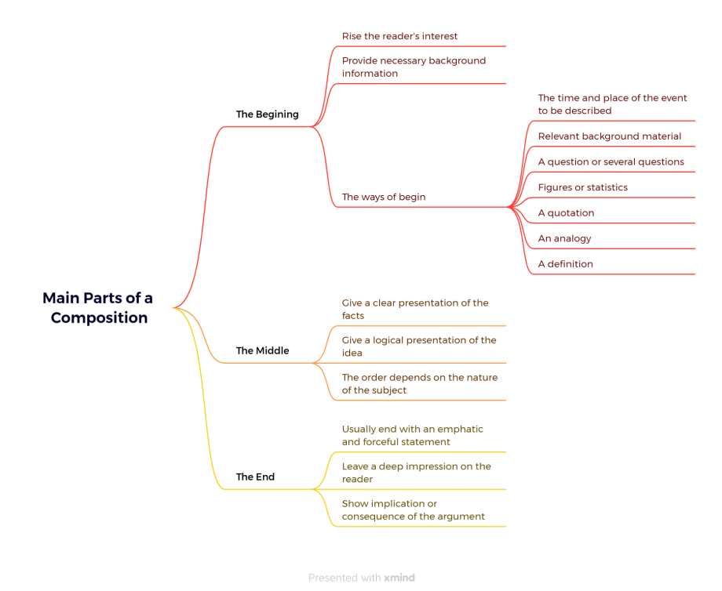

The mind map above is my extracurricular study content.

Here's what we'll learn in class.

First of all, PPT should be visual, clear, concise, but not too simple, need to find a balance.And PPT should choose the appropriate software production, otherwise there may be pre-effect between different equipment errors, leading to unexpected situations.

Secondly, the stage report should be clear, loud, should put an end to hesitancy, small voice. The only way to achieve this effect is with practice.

Finally, learn about writing a paragraph that stands out. A paragraph needs a center, and around the center, to be illustrated by facts and examples, the various forms of sentences should also be flexible use, reasonable expression of their own meaning. The above can be described in an outline and then written.

1. **Learning outcomes**
2. Learned the production method of mind map proficiently, and can skillfully use the way of mind map in the future work report.
3. Learned the nine development ways of paragraphs. Whether it is in my future work or study, such as course papers and graduation papers, I can complete them in an orderly and sequential manner in accordance with certain development ways.
4. Knowing that an article should have a center.Content should be detailed slightly proper. And it needs to be innovative to attract readers. When introducing products or items to others in the future, should also be detailed and interesting.
5. **My behavior and attitude**

I was not very satisfied with my performance this week. Due to my lack of experience in reporting on stage, I hesitated, uttered unclear words and felt at a loss. I practiced hard.

I am not skilled in making PPT, so I need to be more familiar with the operation and continue to learn.

Improve your attitude and enthusiasm to answer questions in class and make persistent efforts.

1. **Improvement**

After class, we also need to practice oral English frequently, improve our oral ability and the ability to report on stage, and correctly do not get stage fright.

Familiar with PPT making and clear presentation of content.